**Interface Definition Document**

**Type of Program: Stopwatch/Timer**

**Team 4: Nathaniel Wilcox | Ezana Girmay | Galib Singh**

**Persona**



**Name:**  Sam Pull

**Age Range:**  15-30

**Activity:**  Running/Jogging/Walking/Cycling

**Use Location:**  Outside

**Traits:**  Orderly, Functional, Competitive

**Goals:**  Faster split times or overall speed, tracking progress

**Mood Board**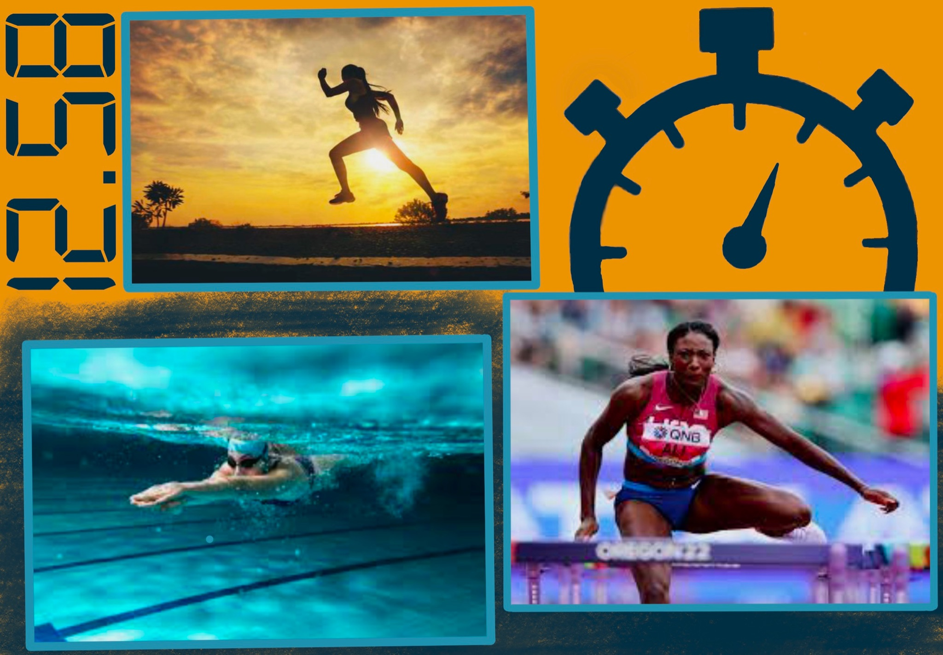

Color Palette

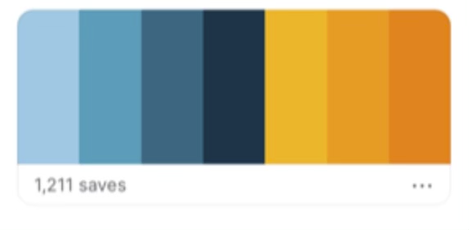

**UI Wireframe**

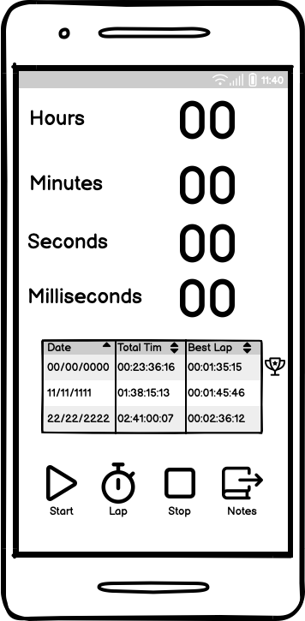 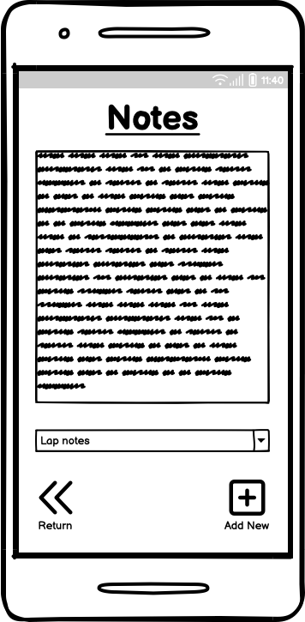

**Navigation Map**

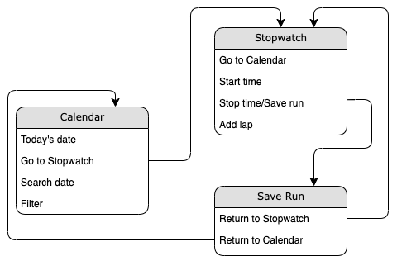

**Entity-Relationship Diagram**

